**Econ 206/Test 2** Write your name on your scantron (-2 if not)

The following data represent ages of 5 consumers:

20, 25, 30, 35, 50

1. The **median** consumer age is

a. 30 b. 32

c. 35 d. none of the above

2. The mean age is

a. $30 b. $32

c. $35 d. none of the above

3. The standard deviation of age is about (pick closest number)

a. 7.5 b. 10.0

c. 11.7 d. 14.2

4. This data is

a. bell-shaped b. skewed toward larger values

c. skewed toward smaller values d. almost perfectly symmetric

5. If average female height is 64 inches with a standard deviation of 2 inches. Then

a. a person 64 inches tall will have a standardized value of 0

b. a person 64 inches tall will have a standardized value of 1

c. a. a person 66 inches tall will have a standardized value of 2

d. none of the above

6. If you have percentile data on outcomes for age for a much larger number of consumers,

a. the interquartile range is the difference between the mean and median

b. the 50th percentile is known as the median

c. the 75th percentile provides information about the skew

d. all of the above

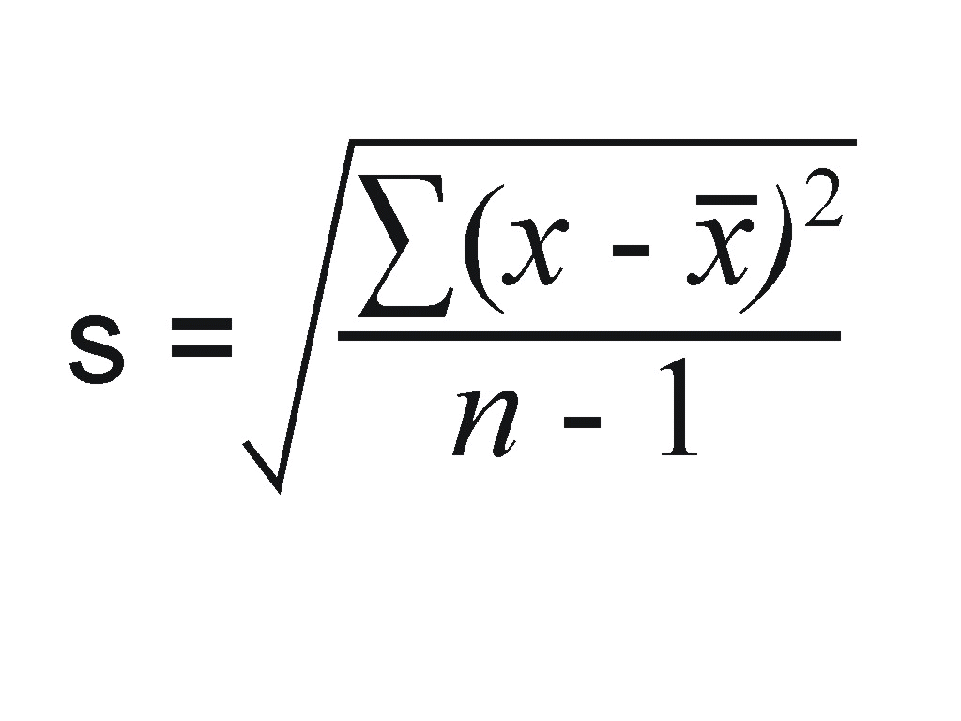

7. If you see the notation this means that you should

a. first add all of observations together and then square them

b. first divide the sum of all observations by the sample size minus 1

c. first take the difference between each observation and the mean

d. none of the above

8. Suppose that the standard deviation for an exam turns out to be very large, this means

a. The class received very similar scores

b. The class received very dissimilar scores

c. The class is negatively skewed

d. The entire class received very high scores

9. When using a variable such as male/female or like/dislike that is treated as a 0,1

a. the mean for the variable is the percentage of values that are 1

b. is the same thing as the sample proportion

c. will be a number between 0 and 1

d. all of the above

The following table provides descriptive statistics on population (in millions)

of 30 metropolitan areas

|  |  |  |  |  |
| --- | --- | --- | --- | --- |
| **Descriptives** | | | | |
|  | | | Statistic | Std. Error |
| cmsa00 | Mean | | 6.3448 | .02666 |
| 95% Confidence Interval for Mean | Lower Bound | 6.2925 |  |
| Upper Bound | 6.3970 |  |
| 5% Trimmed Mean | | 5.7760 |  |
| Median | | 4.6000 |  |
| Variance | | 31.027 |  |
| Std. Deviation | | 5.57021 |  |
| Minimum | | 1.70 |  |
| Maximum | | 21.20 |  |
| Range | | 19.50 |  |
| Interquartile Range | | 5.00 |  |
| Skewness | | 1.664 | .012 |
| Kurtosis | | 1.554 | .023 |

10. Based on the results in the table,

1. the average size of the metro area is 4.6 million
2. the difference between the largest and smallest area is 5.5 million
3. the 50th percentile area is 1.6 million
4. none of the above

11. The number that summarizes the how spread out population is around the mean is

a. 5.5 b. 19.5

c. 1.5 d. none of the above

12. The standardized value for an area with 11.8 million people is

a. 0.0 b. 1.0

c. 1.5 d. 2.6

13. Based on the data in the table, this data is

a. almost perfectly bell-shaped

b. substantially skewed toward larger values

c. substantially skewed toward smaller values

d. none of the above

14. Which of the following accurate:

a. there is more data in the “tails” than a bell-shaped distribution

b. the number that informs about the size of the “tails” is 31.02

c. this data has “skinny tails”

d. none of the above



The figure above displays household income for the U.S.

15. What type of figure is drawn in Exhibit 2?

a. a box plot

b. a stem and leaf plot

c. a scatterplot

d. none of the above

16. Based on the drawing in Exhibit 2, which of the following is accurate?

a. the data have negative skew

b. the mean is larger than the median

c. when population rises, income rises

d. none of the above

17. If you have bell-shaped (normal) data, then you know that

a. about 68% of the values fall between +/- 3 standardized values

b. about 32% of values fall outside of +/- 1 standardized value

c. about 95% of data fall within +/-1 standardized values

d. none of the above

18. Chebyshev’s rule

a. is useful for identifying extreme values when the data are not bell-shaped

b. is also known as the 68-95-99 rule

c. states that 94% of outcomes will be bigger than 1 standardized value

d. all of the above

Correct Answers:

1a, 2b, 3c, 4b, 5a, 6b, 7c, 8b, 9d, 10d, 11a, 12b, 13b, 14a, 15d, 16b, 17b, 18a, 19c, 20b

X-Bar Chart for Hot Chocolate Temperatures

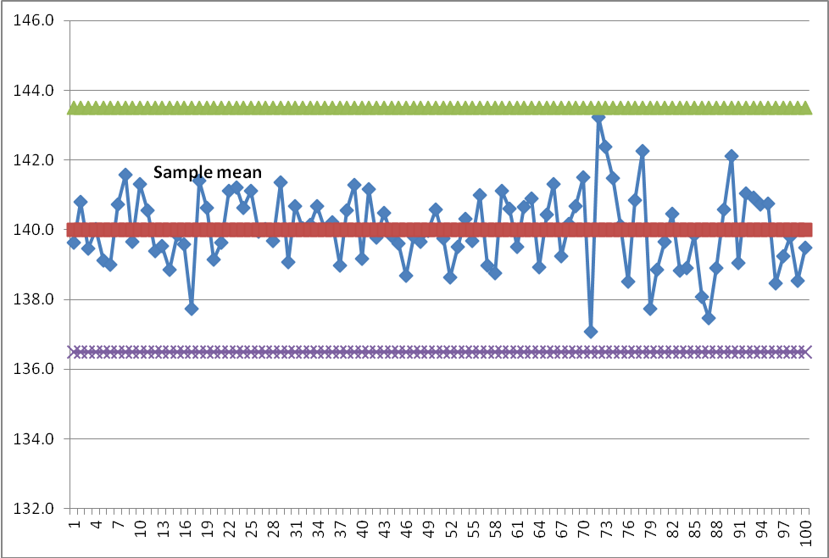

19. The chart above

a. selects the green and purple lines are based on +/- 1 standard deviation

b. uses the idea of Chebyshev’s Rule

c. makes application of the Empirical Rule

d. all of the above

20. Scatterplots

a. are essentially histograms turned on their side

b. chart values for two variables for each observation

c. are the same thing as stem and leaf plots

d. none of the above

21. Put A for your answer